**NSDD Drill November 2020 Answers**01 Dec 2020

LA-UR-20-29807

Approved for public release; distribution is unlimited.

Title: NSDD Drill November 2020 Questions

Author: David J. Mercer and Jennifer L. Auxier

Date: 01 December 2020

This is the answer key for the NSDD “Spectral Flavor of the Month” drill for November 2020. Short answers are shown in red. A longer explanation follows.

This drill involves plutonium and three radionuclides that are sometimes mis-identified as plutonium when measured with a NaI-based instrument. This drill has a difficulty level of 5/10.

The first six questions concern the spectrum "HPGe Plutonium Example". This spectrum was collected using a high-resolution planar-type detector. 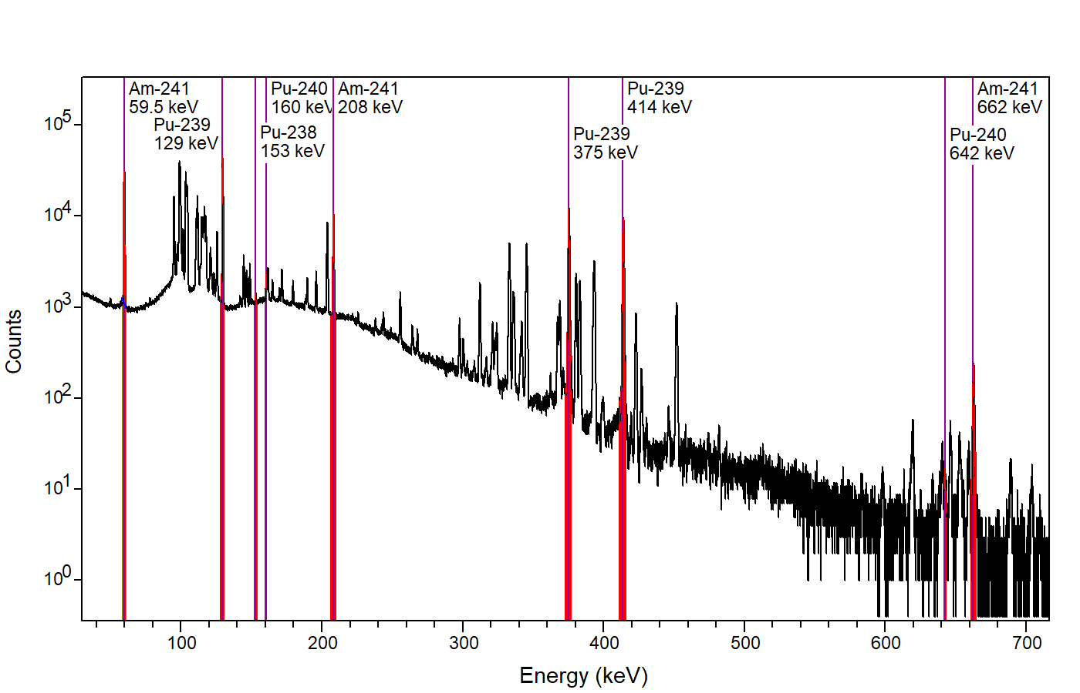

Question 1: Identify three photopeaks from Pu-239.

Three photopeaks from Pu-239 alpha decay are 129.30, 375.05, and 413.71 keV.

There are many more good answers, including 103.06, 116.26, 144.20, 161.45, 171.39, 195.68, 203.54, 332.84, 345.01, 380.17, 393.14, 422.60, 451.48, and 645.90 keV, and others. Because the sample is filtered (See Question 5), lower-energy lines including 38.66 and 51.62 keV are not visible. Several uranium x-rays are visible from plutonium decay, such as 94.65, 98.43, 110.42, and 111.30 keV, but these are not specific to Pu-239.

Question 2: Identify three photopeaks from Pu-241 and/or Am-241 decay chains.

Three photopeaks are 59.54 keV, 208.00 keV, and 662.40 keV

The last of these sometimes overlaps with Cs-137 at 661.66 keV, which can be present in plutonium. There are many more good answers, including 102.98, 125.30, 148.57, and 722.01 keV, and others. Many lines below 371 keV have contributions from both Am-241 alpha decay and U-237 alpha decay following Pu-241 beta decay. The photopeaks at 662.40 and 722.01 are purely from Am-241 alpha decay. A photopeak that is purely from Pu-241 alpha decay is visible at 148.57 keV.

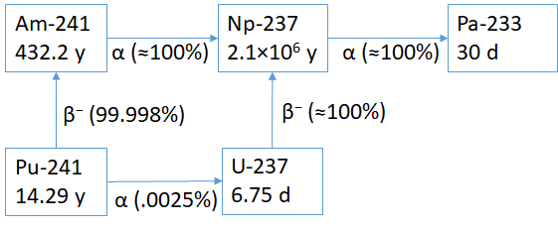

Question 3: Identify two photopeaks from Pu-240. These may be small.

Two photopeaks from Pu-240 decay are 160.31 and 642.35 keV.

A Pu-240 peak at 104.23 keV is also visible as part of an overlapping cluster of peaks.

Question 4: Identify one photopeak from Pu-238. This may be small.

A photopeak from Pu-238 decay is 152.72 keV.

A very weak Pu-238 peak is also visible at 766.38 keV, and a peak at 99.85 keV is visible as part of an overlapping cluster of peaks.

Question 5: Note that fluorescent x-rays are visible at 23 and 26 keV. These come from a filter that was used to reduce intensity of the 59.54 keV photopeak. Is this filter more likely made from cadmium (Cd), tin (Sn), or lead (Pb)?

Cadmium (Cd).

All three of these elements are commonly used as filters. The peak energies seen in the spectrum are a close match to x-rays energies from Cd but not Sn or Pb. The Kα1 and Kα2 x-rays appear as a single peak near 23 keV. A table of characteristic x-rays appears below.

Element Kα1 Kα2 Kβ1

Cd 23.17 keV 22.98 keV 26.10 keV

Sn 25.27 keV 25.04 keV 28.49 keV

Pb 74.97 keV 72.81 keV 84.94 keV

Question 6: If you have an appropriate tool (such as MGA or FRAM), estimate the plutonium isotopic ratios in this example. Is the Pu-240 mass greater than or less than 10% of the total Pu mass?

Less than 10%

FRAM reports:

Pu-238 Mass% 0.0097 ± 0.0006

Pu-239 Mass% 93.802 ± 0.122

Pu-240 Mass% 6.104 ± 0.122

Pu-241 Mass% 0.0584 ± 0.0004

%Am-241/Pu 0.358 ± 0.003

This is typical USA “weapons-grade” plutonium, which has a relatively low Pu-240 content compared to “reactor-grade” plutonium.

The next questions concern four spectra ("Case A", "Case B", "Case C", and "Case D") collected using NaI-based instruments. These instruments do not have internal energy calibration sources. Europium-152 calibration spectra are included for A and B, which use an instrument that has a non-linear calibration. The instrument used for C and D has a reasonably linear energy calibration.

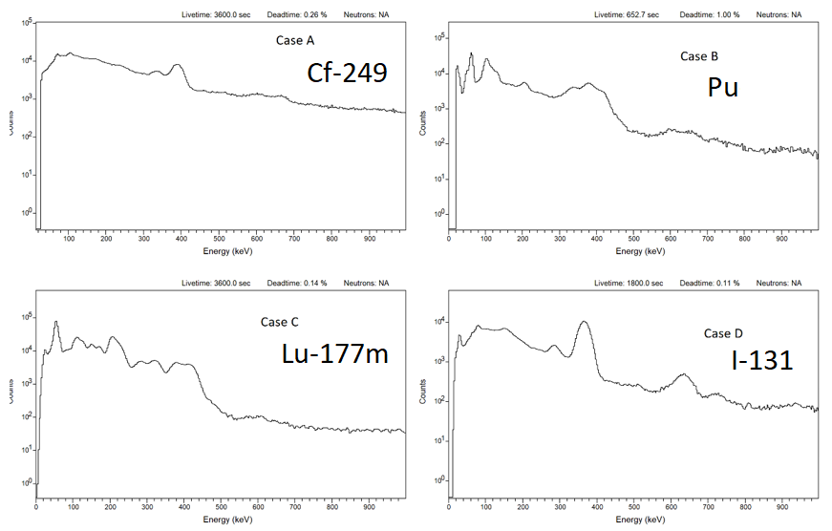

Question 7: Which of the four cases includes actual plutonium?

Case B is actual plutonium.

The “triple hump” near 400 keV is a distinctive feature of plutonium that is recognizable in NaI spectra. The shape of this hump is different for weapons-grade and reactor-grade plutonium, and also changes with age.

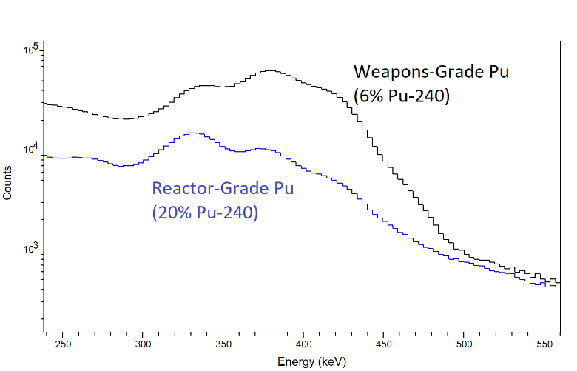

Questions 8-10: What radionuclides are present in the other three cases?

Clue: All three cases are associated with medical or industrial sources; however, the visible radiation may come from a long-lived impurity rather than the principal product.

Case A is Cf-249.

This is a long-lived impurity (half-life 350.5 years) visible in industrial or medical sources of Cf-252 (half-life 2.6 years). Brachytherapy needles with Cf-252 are rare today but were once common. Cf-252 is still common as an industrial or scientific neutron source. Retired sources remain radioactive from the Cf-249 impurity, and sometimes cause plutonium misidentifications. A trace of Cf-251 is also visible, as well as the fission product Cs-137. A Cf-250 impurity (half-life 13 years) is also inferred to be present, and will continue to emit neutrons long after the Cf-252 is gone.

Case C is Lu-177m.

This is a long-lived metastable impurity (half-life 161 days) present in medical sources of Lu-177 (half-life 6.7 days). The use of Lu-177 for cancer therapy is increasing worldwide, mostly for treatment of neuroendocrine tumors. As a result, there have been hundreds of radiation alarms caused by the long-lived Lu-177m in waste streams and in people who have received this treatment. Plutonium misidentifications are very common.

Unlike plutonium, Lu-177m does not emit neutrons.

Case D is I-131.

I-131 is one of the most common medical radionuclides, often used for treatment of hyperthyroidism and thyroid cancer. It also has been involved in many plutonium misidentifications.

Unlike plutonium, I-131 does not emit neutrons.